**Excel Assignment - 6**

1. **What are the various elements of the Excel interface? Describe how they're used.**

The following are the basic parts of the Microsoft Excel Window:

1. **Quick Access Toolbar**

This toolbar is located in the upper left corner of the screen. Its objective is to show the most frequently used Excel commands. We can customize this toolbar based on our preferred commands.

1. **File Tab**

Excel 2007's Office button has been replaced by the File tab. We can click it to **check the Backstage view**, where we can **open** or **save files, create new sheets, print sheets**, and perform other **file-related operations**.

1. **Title Bar**

The title bar of the spreadsheet is at the top of the window. It displays the **active document's name.**

1. **Control Buttons**

Control buttons are the symbols that are present in the **upper-right side** of the window, enabling us to change the **labels, minimize, maximize, share,** and **close the sheet.**

1. **Menu Bar**

the menu bar and contain a **File, Insert, Page Layout, Formulas,** **Data, Review, View, Help,** and a **Search Bar**

1. **Ribbon/Toolbar**

The Ribbon's top part, and they include groups of related commands. Ribbon tabs include **Home, Insert, Page Layout, Formula, Data.**

1. **Dialog Box Launcher**

Dialog box launcher is a very little down arrow that is present in the **lower-right** corner of a command group on the Ribbon. By clicking on this arrow, we can explore more options related to the concerned group.

1. **Name Box**

Show the location of the active cell, row, or column. We have the option of selecting multiple options.

1. **Formula Bar**

Formula bar permits us to observe, insert or edit the information/formula entered in the active cell.

1. **Scroll Bars**

Scrollbars are the tools that enable us to **move the document's vertical** and **horizontal** views.

1. **Spreadsheet Area**

It is the place where we enter our data. It includes all the **rows, cells, columns**, and **built-in data** in the spreadsheet.

1. **Leaf Bar**

Leaf bar is present at the bottom of the spreadsheet, which says **sheet1** is shown. This sheet bar describes the spreadsheet which is currently being worked on.

1. **Column Bar**

Columns are a vertically ordered series of boxes across the full sheet. This column bar is located below the formula bar.

1. **Row Bar Cells**

The row bar is the left part of the sheet where a sequence of numbers is expressed.

1. **Cells**

Cells are those parallelepipeds that divide the spreadsheet into many pieces, separating rows and columns.

1. **Status Bar**

The status bar is present at the bottom of the window that displays critical information. It also indicates whether something is incorrect or whether the document is ready to be printed or delivered.

1. **View Buttons**

View buttons are a set of three buttons arranged at the left of the Zoom control, close the screen's right-bottom corner.

1. **Zoom control**

The zoom control is present at the **lower-right** side of the window.

1. **Write down the various applications of Excel in the industry.**

Excel is powerful software and can help perform a wide range of jobs for personal or business purposes. Therefore, there are plenty of uses of MS excel, and the list goes on.

* Data Entry and Storage
* Performing Calculations
* Data Analysis and Interpretation
* Reporting and Visualizations
* Accounting and Budgeting
* Collection and Verification of Business Data
* Calendars and Schedules
* Administrative and Managerial Duties
* Forecasting
* Automating Repetitive Tasks

1. **On the ribbon, make a new tab. Add some different groups, insert commands in the groups and name them according to their commands added. Copy and paste the screenshot of the steps you followed.**

* Select the data which we have to group
* Go to Data option in menu bar
* Select group and choose the rows or column
* Select subtotal and choose required aggregate function based on columns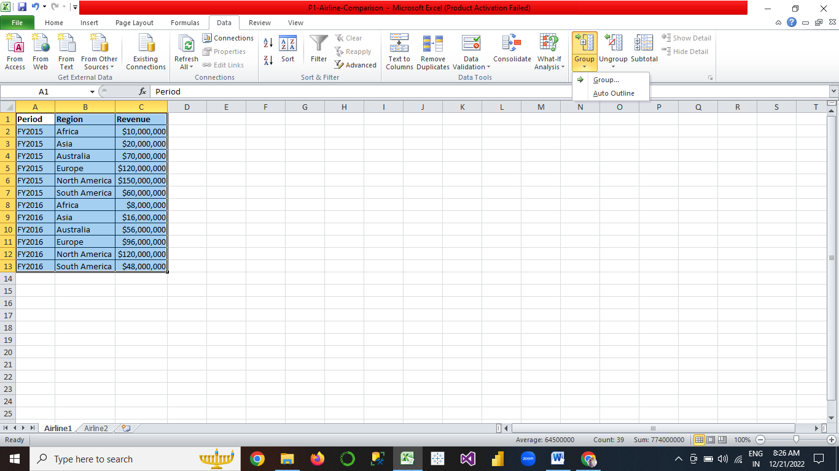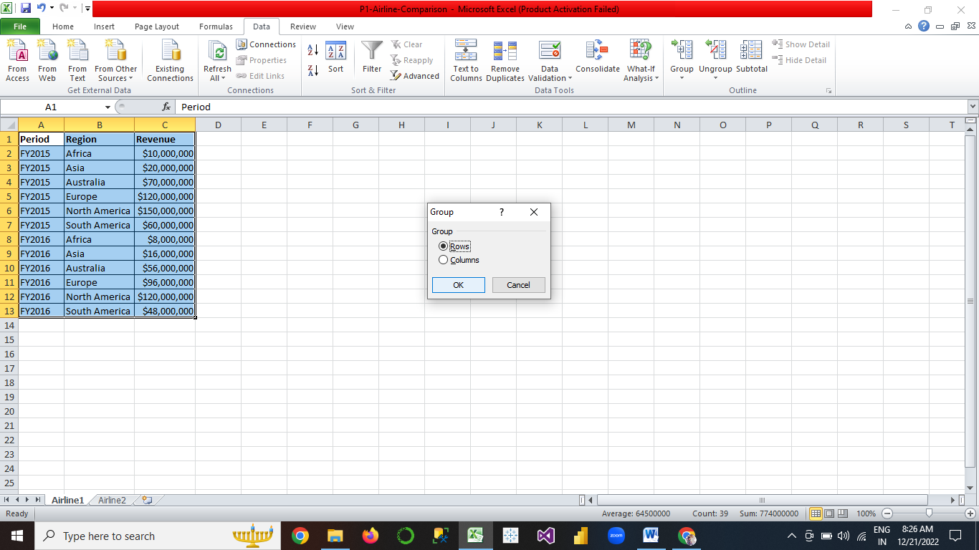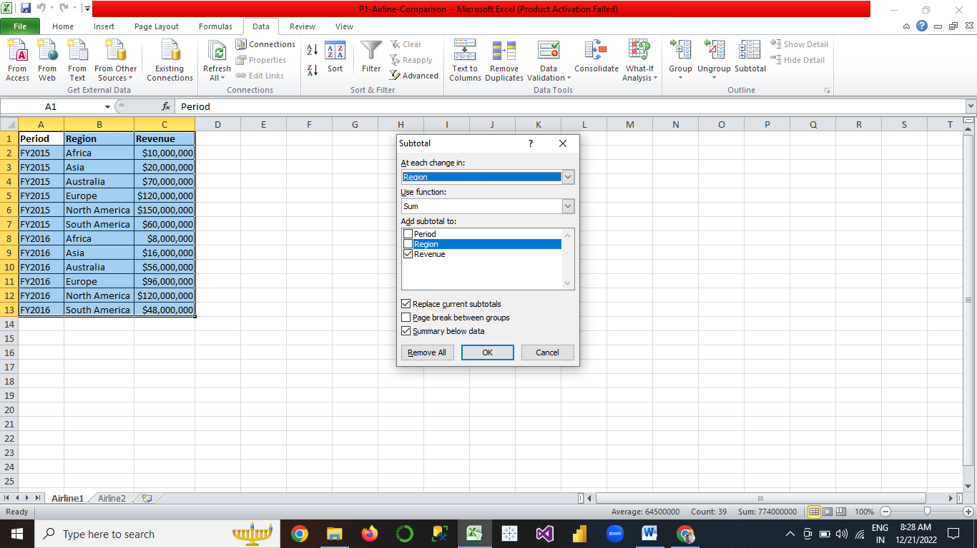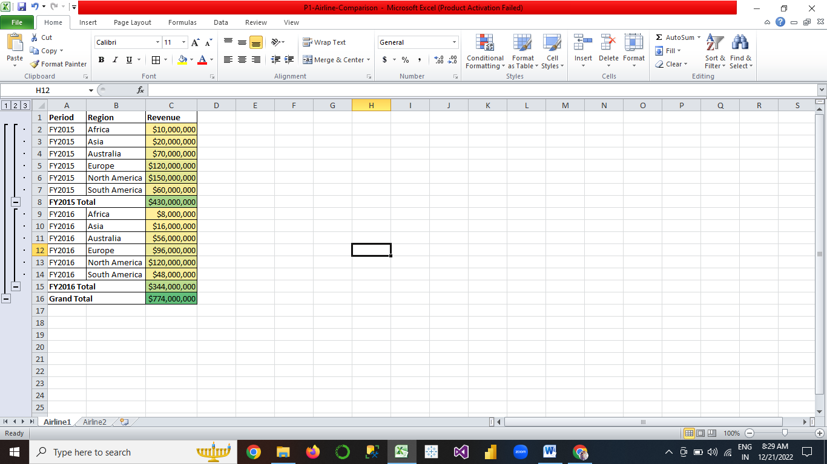

1. **Make a list of different shortcut keys that are only connected to formatting with their functions.**

Formatting Shortcuts:

| To do this | Press |
| --- | --- |
| Display the **Font** dialog box. | Ctrl+D or Ctrl+Shift+F |
| Increase the font size. | Ctrl+Shift+Right angle bracket (>) |
| Decrease the font size. | Ctrl+Shift+Left angle bracket (<) |
| Increase the font size by 1 point. | Ctrl+Right bracket (]) |
| Decrease the font size by 1 point. | Ctrl+Left bracket ([) |
| Switch the text between upper case, lower case, and title case. | Shift+F3 |
| Change the text to all upper case. | Ctrl+Shift+A |
| Hide the selected text. | Ctrl+Shift+H |
| Apply bold formatting. | Ctrl+B |
| Add a bulleted list. | Ctrl+Shift+L |
| Apply underline formatting. | Ctrl+U |
| Apply underline formatting to the words, but not the spaces. | Ctrl+Shift+W |
| Apply double-underline formatting. | Ctrl+Shift+D |
| Apply italic formatting. | Ctrl+I |
| Apply small caps formatting. | Ctrl+Shift+K |
| Apply subscript formatting. | Ctrl+Equal sign ( = ) |
| Apply superscript formatting. | Ctrl+Shift+Plus sign (+) |
| Remove manual character formatting. | Ctrl+Spacebar |
| Change the selected text to the Symbol font. | Ctrl+Shift+Q |

1. **What distinguishes Excel from other analytical tools?**

* Data processing work under general office requirements.
* Data management and storage of small and medium sized companies
* Simple statistical analysis for students or teachers
* Combine Word and PowerPoint to create data analysis reports.
* Assistant tool of data analysts.
* Production of charts for some business magazines and newspapers.

1. **Create a table and add a custom header and footer to your table.**

* Click the worksheet where you want to add or change headers or footers.
* On the **Insert** tab, in the **Text** group, click **Header & Footer**.

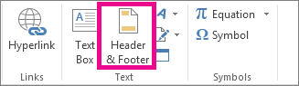

* Excel displays the worksheet in **Page Layout** view.
* To add or edit a header or footer, click the left, center, or right header or footer text box at the top or the bottom of the worksheet page